AP Human Geography
European Migration Summit

Migrants and refugees streaming into Europe from Africa, the Middle East, and South Asia have presented European leaders and policymakers with their greatest challenge. The International Organization for Migration calls Europe the most dangerous destination for irregular migration in the world, and the Mediterranean the world's most dangerous border crossing. Yet despite the escalating human toll, the European Union's collective response to its current migrant influx has been disorganized at best and random at worst and, critics charge, more focused on securing the bloc's borders than on protecting the rights of migrants and refugees. However, with neo-fascist anti-immigrant political parties ascendant in many member states, and concerns about Islamic terrorism looming large across the continent, it remains unclear if the bloc or its member states are capable of implementing lasting asylum and immigration reforms.

Where do these migrants and refugees come from?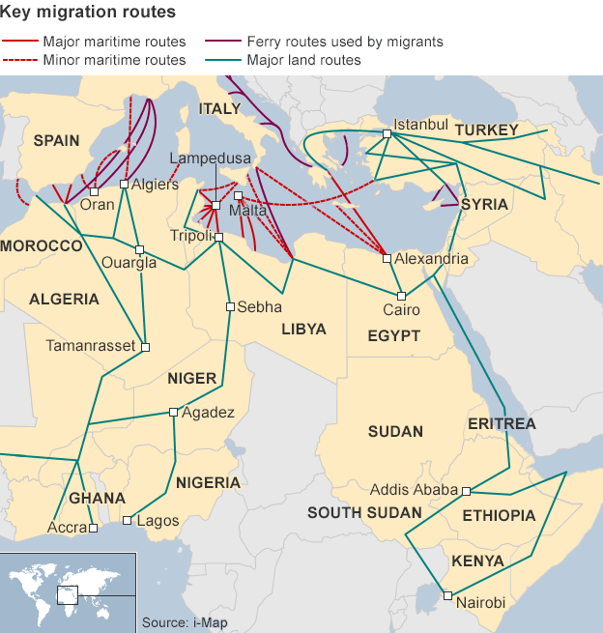
Political upheaval in the Middle East, Africa, and South Asia is reshaping migration trends in Europe. The number of illegal border-crossing detections in the EU started to surge in 2011, as thousands of Tunisians started to arrive at the Italian island of Lampedusa following the onset of the Arab Spring. Sub-Saharan Africans who had previously migrated to Libya followed in 2011–2012, fleeing unrest in the post-Qaddafi era. The most recent surge in detections along the EU's maritime borders has been attributed to the growing numbers of Syrian, Afghan, and Eritrean migrants and refugees.

The IOM estimates that more than 464,000 migrants have crossed into Europe by sea for the first nine months of 2015. Syrians fleeing their country's four-and-a-half-year-old civil war made up the largest group (39 percent). Afghans looking to escape the ongoing war with Taliban rebels (11 percent), and Eritreans fleeing forced labor (7 percent) made up the second and third largest groups of migrants, respectively. Deteriorating security and grinding poverty in Iraq, Nigeria, Pakistan, Somalia, and Sudan have also contributed to the migrant influx.

What’s the difference between a migrant and refugee?
Distinguishing migrants from asylum seekers and refugees is not always a clear-cut process, yet it is a crucial designation because these groups are entitled to different levels of assistance and protection under international law. An asylum seeker is defined as a person fleeing persecution or conflict, and therefore seeking international protection under the 1951 Refugee Convention on the Status of Refugees; a refugee is an asylum seeker whose claim has been approved. However, the UN considers migrants fleeing war or persecution to be refugees, even before they officially receive asylum. (Syrian and Eritrean nationals, for example, enjoy prima facie refugee status.) An economic migrant, by contrast, is person whose primary motivation for leaving his or her home country is economic gain. The term "migrant" is seen as an umbrella term for all three groups. (Said another way: all refugees are migrants, but not all migrants are refugees.)

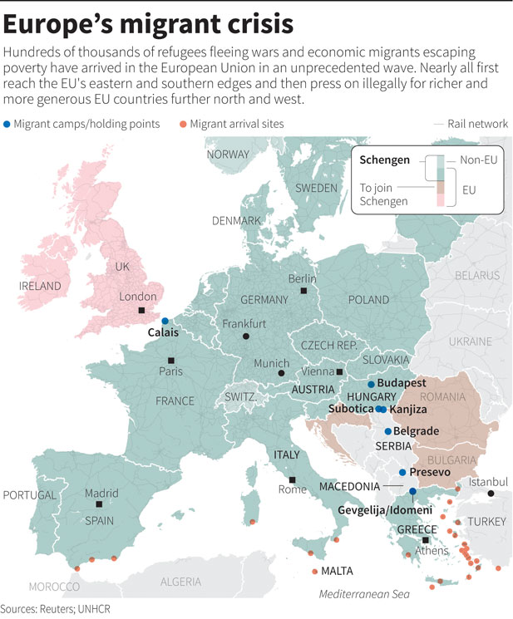

Which EU member states are on the frontlines?
EU member states hardest hit by the economic crisis, like Greece and Italy, have also served as the main points of entry for migrants and refugees due to their proximity to the Mediterranean Basin. Shifting migratory patterns over the past year have also exposed countries like Hungary, situated on the EU's eastern border, to a sharp uptick in irregular migration.

Greece: By 2012, 51 percent (PDF) of migrants entering the EU illegally did so via Greece. This trend shifted in 2013 after Greek authorities enhanced border controls under Operation Aspida (or "Shield"), which included the construction of a barbed-wire fence at the Greek-Turkish border. But by July 2015, Greece had once again become the preferred Mediterranean entry point, with Frontex reporting 132,240 illegal EU border crossings for the first half of 2015, five times the number detected for the same period last year. Syrians and Afghans made up the "lion's share" of migrants traveling from Turkey to Greece (primarily to the Greek islands of Kos, Chios, Lesbos, and Samos) in the first seven months of 2015. This most recent migrant surge coincided with the country's tumultuous debt crisis, which brought down its banking system and government this summer.

Italy: The Central Mediterranean passage connecting Libya to Italy was the most trafficked route for Europe-bound migrants in 2014: Frontex reported more than 170,000 illegal border crossings into Italy. In October 2014, the country's Mare Nostrumsearch-and-rescue program, credited for saving more than 100,000 migrants, was replaced by Frontex's Triton program, a smaller border-control operation with a third of Mare Nostrum's operating budget. In April 2015, EU leaders tripled the budget for Frontex's Triton border patrol program to 9 million euros a month ($9.9 million), but refused to broaden its scope to include search and rescue. While the number of illegal border crossings into Italy for the first half of 2015 remained high at 91,302, the rising death toll (the IOM estimates that more than 2,000 people died along this route in 2015) and the deteriorating security situation in Libya have pushed many migrants to seek out alternate paths to Europe through Greece and the Balkans. Ninety percent of the migrants using this route in the first half of 2015 were from Eritrea, Nigeria, and sub-Saharan Africa.

Hungary: A growing number of Syrians and Afghans traveling from Turkey and Greece through Macedonia and Serbia have made this EU member state the latest frontline in Europe's migration crisis. (A growing number of citizens from Kosovo traveling through Serbia also contributed to Hungary's migrant influx this year.) From January to July 2015, Frontex reported 102,342 illegal crossings into Hungary. This surge prompted Prime Minister Viktor Orban to erect a barbed-wire fence on the border with Serbia in July 2015. In April 2015, a public opinion survey (PDF) found that 46 percent of polled Hungarians believed that no asylum seeker should be allowed to enter Hungary at all. Stranded migrants, barred from boarding westbound trains, effectively transformed Budapest's Keleti station into a makeshift refugee camp in September 2015.

What is the Dublin Regulation?
Entry-point states bear sole responsibility for migrants under the Dublin Regulation. Revised in 2013, this EU law stipulates that asylum seekers must remain in the first European country they enter and that country is solely responsible for examining migrants' asylum applications. Migrants who travel to other EU states face deportation back to the EU country they originally entered.

Many policymakers agree that reforming the Dublin Regulation is an important step to establishing a common European asylum policy. Under the current system, the burden of responsibility falls disproportionately on entry-point states with exposed borders. In practice, however, many of these frontline countries have already stopped enforcing Dublin and allow migrants to pass through to secondary destinations in the north or west of the EU. Germany and Sweden currently receive and grant the overwhelming majority of asylum applications in the EU.
"Both the burden and the sharing are in the eye of the beholder. I don't know if any EU country will ever find the equity that is being sought," says Center for Strategic and International Studies Senior Fellow Heather Conley.

What conditions do these migrants face in Europe?
Migrant detention centers across the continent, including in France, Greece, and Italy have all invited charges of abuse and neglect over the years. Many rights groups contend that a number of these detention centers violate Article III (PDF) of the European Convention on Human Rights, which prohibits inhuman or degrading treatment.

“We used to think of migration as a human security issue: protecting people and providing assistance,” says Brookings Institution’s Senior Fellow Khalid Koser. “Now we clearly perceive—or misperceive—migration as a national security issue. And the risk of securitizing migration is that you risk legitimizing extraordinary responses.”
In Italy, migrants face fines and deportation under the controversial Bossi-Fini immigration law, which stipulates that migrants must secure work contracts before entering the country. This 2002 law makes illegal migration—and aiding illicit migrants—punishable by fine or jail. In Greece, the prolonged detention of migrants and asylum seekers, who are sometimes “mixed in with criminal detainees,” has elicited repeated censure from rights groups. And in Hungary, a new series ofemergency laws adopted in September 2015 will allow its police to operate detention centers, in addition to making illegal border crossings and aiding migrants punishable by prison time. The government also deployed armed troops to its border.

Budgets for migration and asylum issues in many of these entry-point states hardest hit by the economic crisis have not kept up with growing demands and needs. In August 2015, the European Commission approved a 2.4 billion euro ($2.6 billion) emergency aid package, with 560 million euros ($616 million) earmarked for Italy and 473 million euros ($520 million) for Greece to subsidize their migrant-rescue efforts for the next six years. However, many policymakers say that these funds still fall short of the growing magnitude of the crisis.In contrast, migrants in the richer north and west find comparatively well-run asylum centers and generous resettlement policies. But these harder-to-reach countries often cater to migrants who have the wherewithal to navigate entry-point states with the assistance of smugglers. These countries still remain inaccessible to many migrants seeking international protection.

How has the European Union responded?
As with the sovereign debt crisis, national interests have consistently trumped a common European response to this migrant influx. Some experts say the bloc's increasingly polarized political climate, in which many nationalist, anti-immigrant parties are ascendant, is partially to blame for the muted humanitarian response from some states. Countries like France and Denmark have also cited security concerns as justification for their reluctance in accepting migrants from the Middle East and North Africa, particularly in the wake of the Paris and Copenhagen terrorist shootings in early 2015.

Underscoring this point, leaders of eastern European states like Hungary, Poland, Slovakia, and the Czech Republic have all recently expressed a strong preference for non-Muslim migrants. In August 2015, Slovakia announced that it would only accept Christian refugees from Syria. Poland has similarly focused on granting Syrian Christians asylum, and the head of the country's immigration office admitted to the Financial Times that, "[applicants'] religious background will have [an] impact on their refugee status applications." And in Hungary, Prime Minister Viktor Orban has explained his anti-migrant policies in explicitlyanti-Muslim language. While selecting migrants based on religion is in clear violation of the EU's non-discrimination laws, these leaders have defended their policies by pointing to their own constituencies' discomfort with growing Muslim communities.
The recent economic crisis has also spurred a demographic shift across the continent, with citizens of crisis-hit member states migrating to the north and west in record numbers in search of work. And while the issue of intra-EU migration has sparked anxiety over social welfare benefits in recent months, "those who are coming from the Middle East and North Africa tend to provoke more heated political debate because of this issue of communal cleavage and integration," says Kupchan.

By contrast, Germany and Sweden have unveiled some of the most generous asylum policies in the EU. In September 2015, Berlin pledged 6 billion euros ($6.6 billion) to support the 800,000 migrants—about quadruple the number from 2014—it was expecting to receive by the end of 2015. "If Europe fails on the question of refugees," warned German Chancellor Angela Merkel, "then it won't be the Europe we wished for." German officials also signaled that the country was prepared to take "500,000 asylum seekers a year" for several years. Similarly, Sweden's liberal asylum policies have spurred a dramatic uptickin applications. Measured on a per capita basis, the country granted refuge to the largest share of EU applicants (317.8 per 100,000) in 2014. Stockholm had previously announced that it would offer permanent residency to all Syrian applicants in 2013.

Some experts say Germany and Sweden's open immigration policies also make economic sense, given Europe's demographic trajectory (PDF) of declining birth rates and ageing populations. Migrants, they argue, could boost Europe's economies as workers, taxpayers, and consumers, and help shore up its famed social safety nets. But others caution that EU citizens might come to regard migrants as economic competitors, not contributors. Brookings' Koser says the demographic argument presents a political paradox for some member states. "You have 50 percent youth unemployment in Spain, and yet Spain needs migrants. That's just a very hard sell," he says.

What is the Schengen Zone?
The secondary movements of migrants who evade their first country of entry, in clear violation of the Dublin Regulation, have put enormous strain on the EU's visa-free Schengen zone, which eliminated border controls among twenty-six European countries. Considered one of the signature achievements of European integration, it has come under heightened scrutiny in light of the current migrant influx and attendant security concerns. (Fissures first surfaced in April 2011, when France brieflyreintroduced border controls in response to the influx of thousands of Tunisian and Libyan refugees from neighboring Italy. Denmark followed suit in May 2011 by reintroducing temporary controls on its shared borders with Sweden and Germany.)

In August 2015, Germany announced that it was suspending Dublin for Syrian asylum seekers, which effectively stopped deportations of Syrians back to their European country of entry. This move by the bloc's largest and wealthiest member country was seen as an important gesture of solidarity with entry-point states. However, German Chancellor Angela Merkel also warned that the future of Schengen was at risk unless all EU member states did their part to find a more equitable distribution of migrants.

Germany reinstated border controls along its border with Austria in September 2015, after receiving an estimated forty thousand migrants over one weekend. Implemented on the eve of an emergency migration summit, this move was seen by many experts as a signal to other EU member states about the pressing need for an EU-wide quota system. Austria, the Netherlands, and Slovakia soon followed with their own border controls. These developments have been called the greatest blow to Schengen in its twenty-year existence.

While Schengen rules allow member countries to erect temporary border controls under extenuating "public policy or national security" circumstances, CSIS' Conley fears that a sustained influx of migrants could spur more member states to suspend borderless travel for longer stretches of time. "I suspect if the politics surrounding migration really start getting messy, you'll see countries reintroducing internal borders with greater frequency, which means they would have chiseled away at one of the main pillars of Europe, which is the free movement of people," she says.

What are the main proposals for managing the crisis?
In September 2015, EU ministers agreed to resettle 120,000 migrants—a small fraction of those seeking asylum in Europe—from Greece and Italy across twenty-three member states. (Greece and Italy will not be required to resettle more migrants, and Denmark, Ireland, and the UK are exempt from EU asylum policies under provisions laid out in the 2009 Lisbon Treaty.) This plan was approved despite the vocal objections of the Czech Republic, Hungary, Romania, and Slovakia. This agreement builds upon a previous voluntary quota system that called on member states to resettle forty thousand migrants from Greece and Italy over a two-year period. Critics of this approach argue that free movement inside the Schengen zone effectively nullifies national resettlement quotas.

In addition to taking in larger numbers of asylum seekers, many experts say the EU and global powers must also provide more aid to Middle Eastern countries like Turkey, Lebanon, and Jordan, which have borne the primary responsibility for Syrian refugees. According to the UNHCR, 1.9 million Syrians have taken refuge in Turkey, 1.1 million in Lebanon, and 630,000 in Jordan since the start of the conflict in 2011.This influx has altered the demographics and economies of these host countries, which are now struggling to provide basic food and shelter due to funding shortages. (Since 2011, the United States has spent more than $4 billion on Syria humanitarian assistance, but has only given refuge to 1,500 Syrians. In September 2015, U.S. Secretary of State John Kerry announced that the United States would accept an additional ten thousand Syrians in 2016, and an additional thirty thousand global refugees over the next two years.)

Some policymakers, like European Council President Donald Tusk, have called for asylum centers to be built in North Africa and the Middle East to enable refugees to apply for asylum without undertaking perilous journeys across the Mediterranean, as well as cutting down on the number of irregular migrants arriving on European shores. However, critics of this plan argue that the sheer number of applicants expected at such "hotspots" could further destabilize already fragile states.

Other policies floated by the European Commission include drawing up a common "safe-countries list" that would help countries expedite asylum applications and, where needed, deportations. Most vulnerable to this procedural change are migrants from the Balkans, which lodged 40 percent of the total asylum applications received by Germany in the first six months of 2015. However, some human rights groups have questioned the methodology used by several countries in drawing up these lists and, more critically, cautioned that such lists could violate asylum seekers' rights.

A ten-point plan on migration adopted by the EU in April 2015 includes calls for a "systematic effort to capture and destroy vessels used by the smugglers." However, many critics argue that this focus on disrupting smuggling operations fails to recognize the larger "push factors" driving migration to the region: poverty and conflict across large swaths of the Middle East, Africa, and South Asia that have left many with no recourse but to flee.
In May 2015, the EU foreign policy chief, Federica Mogherini, sought UN Security Council authorization for the use of military force against human smugglers and their vessels off the shores of Libya. Libya's internationally recognized government, however, promptly rejected the proposal, and Russia, a permanent member of the UN Security Council, also signaled that it would veto any proposal that aimed to destroy smugglers' boats. In September 2015, Mogherini announced plans to revisit the issue of destroying smugglers' boats with both a Libyan national unity government and the UN Security Council.

"The political response of countries pushing migrants out or incarcerating them for long stretches runs counter to the very values that the EU promotes, like protecting human life and the right to asylum."—Heather Conley, Center for Strategic and International Studies

Quota plans and naval operations may help EU member states better manage this crisis, but experts caution that these proposals alone will not stem the tide of migrants. For that, European leaders must address the root causes of migration: helping to broker an end to Syria's civil war, restoring stability to Libya, and upping aid to sub-Saharan Africa. Barring a political solution to these regional crises, Europe will continue to struggle with migrant inflows.
In the meantime, the lack of a coordinated and proportional EU response to irregular migration in the near-to-mid-term could continue to feed sentiments that push individual countries to emphasize national security over international protection. This could make closed borders, barbed-wire fences, and maritime pushbacks the policy norm rather than the exception.

But for CSIS' Conley, such practices would not just imperil migrants and refugees, but also the very ideals upon which the EU was founded. "The political response of countries pushing migrants out or incarcerating them for long stretches runs counter to the very values that the EU promotes, like protecting human life and the right to asylum," she says.

QUESTION: What is the best course of action for the European Union to take to deal with their Migration Crisis?
- your group should consider the following:
  - What is your region’s role in the current crisis? (Are you a point of origin, a transition point or a destination for the migrants? What are the pull and push factors involved?)
  - How do the current EU regulations impact your role in the crisis? (The Dublin Regulations and the Shengen Zone regulations)
  - What is your regional attitude to the migrants? How have they been received? Does it matter if they are an economic migrant or a refugee?
  - Finally - what new regulations should be agreed to to make sure that both the Universal Declaration of Human Rights are followed and national interests are also protected.
Each Group will present their position to the rest of the summit and then the summit will produce an output document based on a compromise between the parties.
Group 1: Northern Europe
Germany
Sweden
Group 2: Southern Europe
Hungary
Greece
Italy
Group 3: Refugees from the Middle East – Syria
Group 4: Migrants from Africa - Eritrea

